**PROJECT REPORT**

**COMPOSE INPUT : A DEMONSTRATION OF TEXT INPUT AND VALIDATION WITH ANDROID COMPOSE**

**1.INTRODUCTION**

**1.1 OVERVIEW**

Text is a central piece of any UI, and Jetpack Compose makes it easier to display or write text. Compose leverages composition of its building blocks, meaning you don’t need to overwrite properties and methods or extend big classes to have a specific compostable design and logic working the way you want. The app is a sample project that demonstrates how to use the Android Compose UI toolkit to build a survey app. The app allows the user to answer a series of questions. It showcases some of the key features of the Compose UI toolkit, data management, and user interactions.

**1.2 PURPOSE**

1) Keyboard isn’t opened upon entering the screen.

2) No Text Field is focused upon entering the screen.

3) There is no way to tell which Text Field was focused last, after process death occurred.

4) No Impactions handling for the name Text Field.

5) Keyboard isn’t dismissed upon successful button click.

6) Focused Text Field is not unfocused upon successful button click

**2. PROBLEM DEFINITION & DESIGN THINKING**

**2.1 EMPATHY MAP**

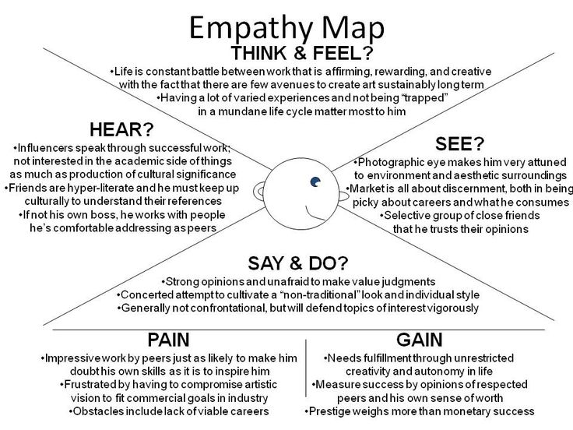

**2.2 IDEATION & BRAINSTORMING MAP**

* **Mapping:** You might be mapping a test group of customers or a client who wants a new app designed, for example. You may like to represent these target groups using a persona – a fictional archetype of a customer or stakeholder.
* **Main Goal:** Will set the direction for the rest of the mapping process. It may be useful to use Customer Experience Mapping to pinpoint specific "touch points" that you want to address. If the stakeholder has asked a specific question about the situation that you're investigating, or has made a particular request, record it here.
* **Collect Relevant Data:** Empathy Mapping works best if it's based on the actual thoughts, feelings and perceptions of its subjects. So, as part of your development process, you should collect a range of data on your stakeholders' experiences.Make sure that everyone involved in the mapping exercise reads the data in advance, and understands the subject and the scope of the investigation.
* **Start to Fill in the Map:** Now that you've taken the preliminary steps, you and your team can start to work on your Empathy Map. Start with the "What do they SEE?" Section on the right of the map. Think through the subsidiary questions here, together, and always base your responses on research and feedback that you've gathered
* **Complete the Outer Sections of the Map :** Moving clockwise around the map, repeat what you've done in step three for steps four, five and six.Be guided in each case by the subsidiary questions. As far as possible, use language that the subjects themselves would use, and try not to summarize or interpret
* **Reflect on What You've Discovered :**Now, you and your team can take a step back and review what you've come up with. If possible, ask other relevant colleagues to review and "sense check" what you've created, and to offer their thoughts and suggestions
* **Draw Conclusions and Take Action :**At the center of your map you now have a clear picture of how your stakeholders or customers feel about their situation, or what they need.This is the basis for a plan of action that puts empathy and emotional intelligence at the center of the process.

**3 RESULT**

**Admin Module:** After logging in with admin credentials which are hard coded

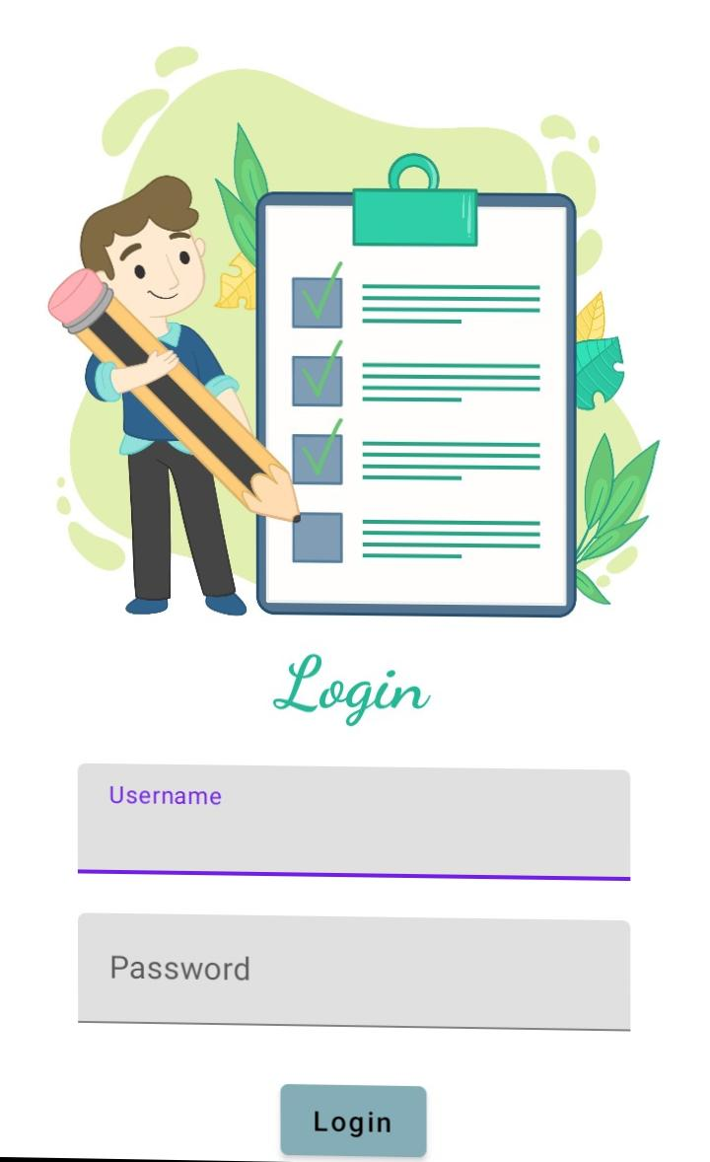**Login page:**

**Register Page:**

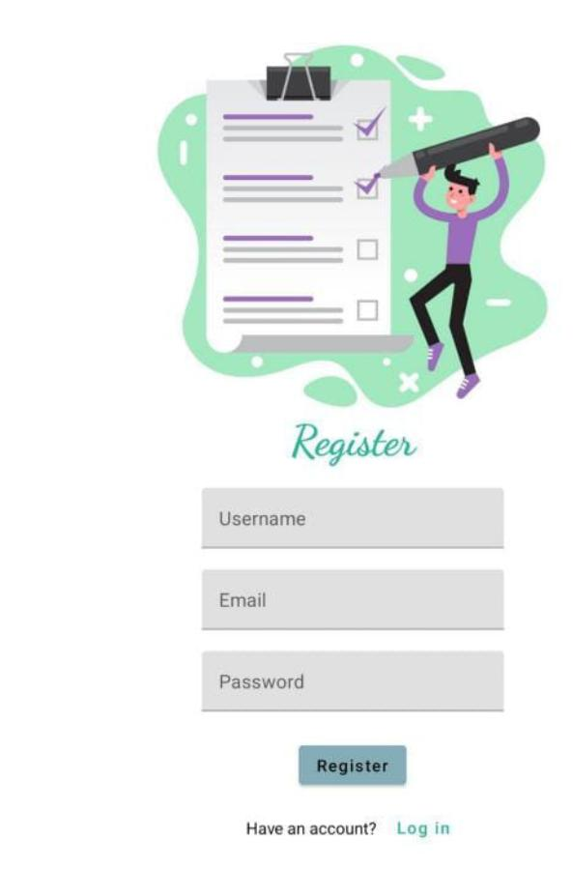

**Admin Page :**

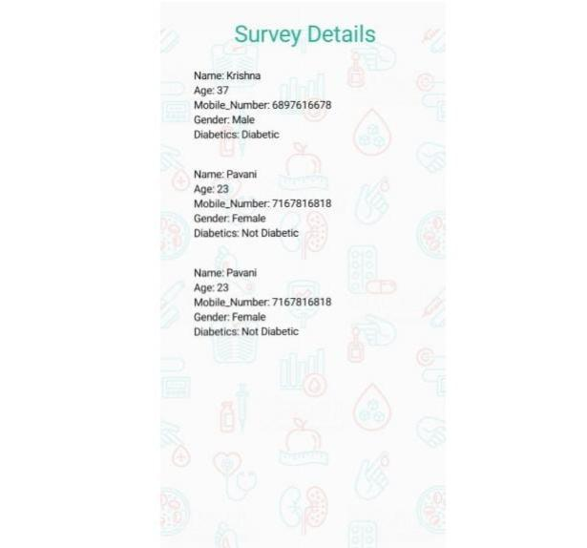

**User Module:**

**Login Page:**

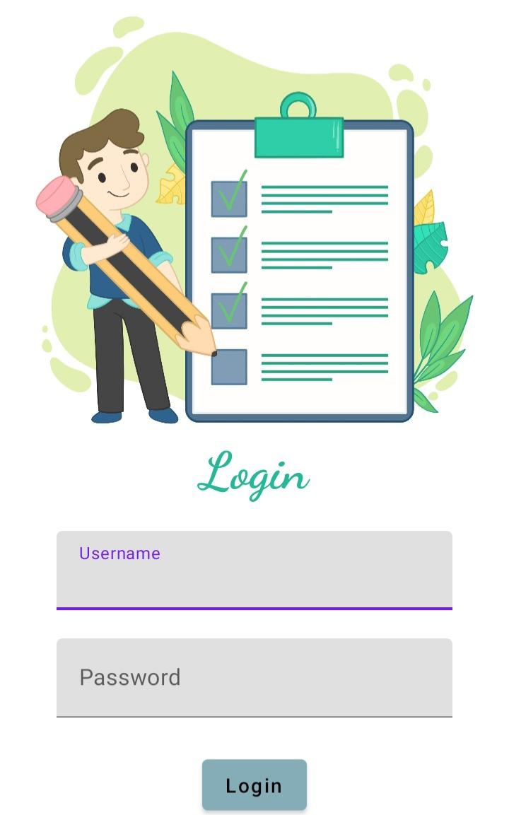

**Register Page:**

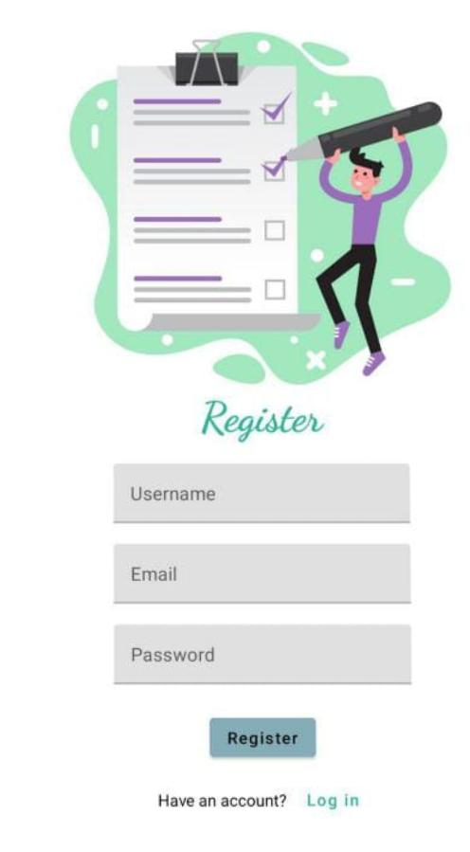

**Main page:**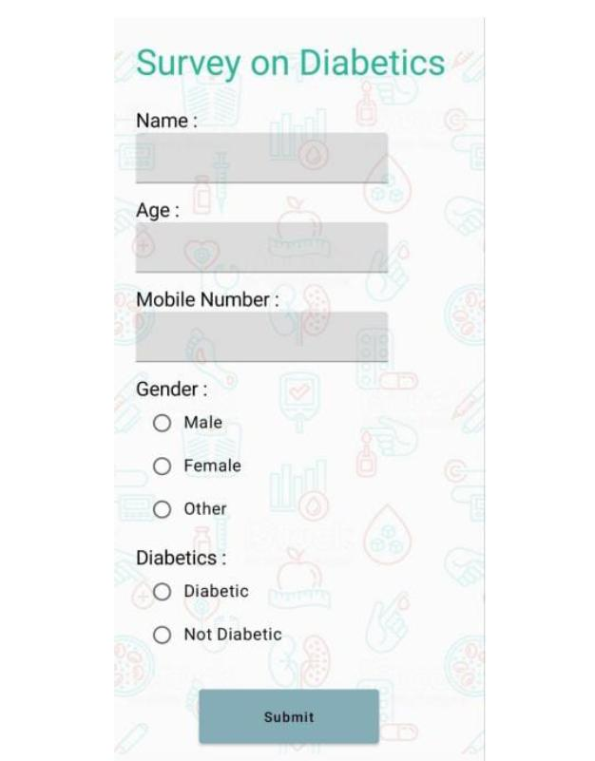

**4.TRAILHEAD PROFILE PUBLIC URL**

**Team lead –** SANGEETHA.A <https://trailblazer.me/id/siibsccs>

**Team Member 1-** VAISHNAVI.V. <https://trailblazer.me/id/vaisv15>

**Team Member 2-** MAHENDRAN S <https://trailblazer.me/id/mselva115>

**Team Member 3-** MOHANRAJ.S. https://trailblazer.me/id/uthamouli

**5.ADVANTAGES &DISADVANTAGES:**

**Advantages of Demonstration Method :**

* It helps in involving various sense to make learning permanent
* Though, teacher behaviour is autocratic, he invites the cooperation of pupils in teaching learning process
* It develops interest in the learners and motivates them for their active participation
* It helps in achieving psychomotor objectives
* Any simple or complex sill becomes easy to understand

**Disadvantages of Demonstration Method:**

* It can be used only for skills subjects
* Only the attention of the learners is invited towards the activity demonstrated. They are not free to discuss about it
* Due to poor economic conditions of the government schools, there is scarcity of audio-visual aids and equipment and the teachers are not so creative to produce handmade models for demonstration
* There is a general lack of sincerity and diligence among teachers who wish to complete the syllabus or syllabi at the earliest without putting sincere efforts

**6. APPLICATION**

This strategy is applied mainly in technical or training institutes. In teacher education programs it is used to develop skills in the student teacher. At school level, a teacher applies it in teaching science, biology, nature study arts and crafts.

* The demonstration should be carried out in a simple and easy manner. way.
* In this strategy, full attention should be paid to all the students in the class.
* Goals and objectives of the demonstration should be very clear.
* It should be carried out with a well-planned strategy.
* A set Time should be dedicated to the rehearsal before the demonstration.

**7. CONCLUSION**

In conclusion, we can say that survey is a very productive activity both for the knowing about information of people and the government. As they support each other simultaneously. Also, the government should consider improving the conditions of the country as more and more number of survey gathering apllication.

**8.FUTURE SCOPE**

As technology continues to change the world of land surveying, developments are moving into an entirely new realm of near-complete automation: Drones, or unmanned aerial vehicles, can collect data quickly and easily over large areas and rough terrain. Travel and tourism industry is no longer hidden and gone are the days when travelling the world was like an unknown step. It has transformed and technology has reinvented the different ways to explore travelling for you so that you will find places easily.

**9. APPENDICES**

1. **SOURCE CODE**

<?xml version="1.0" encoding="utf-8"?>

<manifest xmlns:android="http://schemas.android.com/apk/res/android"

xmlns:tools="http://schemas.android.com/tools">

<application

android:allowBackup="true"

android:dataExtractionRules="@xml/data_extraction_rules"

android:fullBackupContent="@xml/backup_rules"

android:icon="@mipmap/ic_launcher"

android:label="@string/app_name"

android:supportsRtl="true"

android:theme="@style/Theme.TravelApp"

tools:targetApi="31">

<activity

android:name=".RegisterActivity"

android:exported="false"

android:label="RegisterActivity"

android:theme="@style/Theme.TravelApp" />

<activity

android:name=".SingaporeActivity"

android:exported="false"

android:label="@string/title_activity_singapore"

android:theme="@style/Theme.TravelApp" />

<activity

android:name=".ParisActivity"

android:exported="false"

android:label="@string/title_activity_paris"

android:theme="@style/Theme.TravelApp" />

<activity

android:name=".BaliActivity"

android:exported="false"

android:label="@string/title_activity_bali"

android:theme="@style/Theme.TravelApp" />

<activity

android:name=".MainActivity"

android:exported="true"

android:label="@string/app_name"

android:theme="@style/Theme.TravelApp"/>

<activity

android:name=".LoginActivity"

android:exported="true"

android:label="@string/app_name"

android:theme="@style/Theme.TravelApp">

<intent-filter>

<action android:name="android.intent.action.MAIN" />

<category android:name="android.intent.category.LAUNCHER" />

</intent-filter>

</activity>

</application>

</manifest>